1. Requirements
2. OS
   1. OpenSuse 13.1 x86-64
   2. Ubuntu 12.04/14.04 x86-64
3. Security on all machines
   1. <add key="RoleBasedSecurity" value="0" />

For Windows-based machines run the command under cmd:

C:\Users\Administrator\Desktop>PRM_VMBackup_3.31.2215.258925_20151005.exe RoleBasedSecurity=0

For Linux-based machine the security already switched off in the config files

1. Packages :
   1. mono-core-3.0.6
   2. mono-extras-3.0.6
   3. libsqlite 3-0
   4. libsmbclient (for work with UNC Storage on PRM Backup server)
   5. vddk-5.5.1 (<http://portal.paragon-software.com/SiteDirectory/cto/Development%20Documents/PRM/Features/Linux%20Backup/Install_vddk_on_openSuse.docx>)
   6. dmidecode
   7. chkconfig (only for OpenSuse)
   8. update-rc.d (only for Ubuntu. See [bug 87847](http://bugzilla.paragon-software.com/show_bug.cgi?id=87847) )
   9. insserv (only for OpenSuse)
2. Opened Firewall ports
   1. 135, 18950,60543,60544,65000
3. Network
   1. Machine must be available by its DNS name (w/o domain zone)
4. Installation package

You can get package from TeamCity configuration [202 DISTRIBUTIVE](http://vmsk-tc-prm.paragon-software.com/viewType.html?buildTypeId=Prm_Builds_202distributiveLi) artifacts:

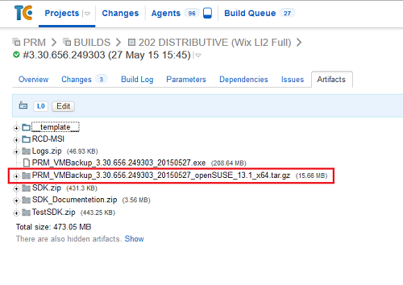

1. Preparing
   1. Extract all files from PRM_VMBackup_*_openSuse_13.1_x64.tar.gz
   2. Copy package in to target machine
2. Install PPR

sh <extract_dir>/ppr-distrib/install.sh [-p <installation_dir>] [-d <ppr_data_dir>] [-r <roles>] [-s <adminserver>]

#Get help and default values

sh ./install.sh –help

#Example 1 – install primary roles:

sh ./install.sh –r “AdminServer,BackupServer”

#Example 2 – install PhysicalAgent and Volumes and LinuxAgent application add machine in to PRM infrastructure on w630s64-XX-YY machine:

sh ./install.sh -r "PhysicalAgent[Volumes|LinuxAgent]" –s w630s64-XX-YY

#Example 3 – install PhysicalAgent and LinuxAgent application and BackupServer and add machine in to PRM infrastructure on w630s64-XX-YY machine

sh ./install.sh -r "PhysicalAgent[LinuxAgent],BackupServer" –s w630s64-XX-YY

1. Uninstall PPR

/etc/init.d/prm30 stop

/etc/init.d/prm.diagnostics.service stop

rm –rf /etc/init.d/prm*

rm –rf /<ppr_data_dir> (by default /opt/ppr/)

1. Troubleshooting :
   1. **Error : Compatibility verification failed: Mono version doesn’t meet requirements.**

In this case you can try, reinstall Mono on the required version.

Or you can edit “install.sh” script :

1. Open install.sh by any linux text editor
2. Find the string “REQUIRED_MONO="[34]\.0\.[0-9]+" # Regular expression for Mono version”
3. Change on REQUIRED_MONO=".*" and save script.
4. Try install again
   1. **Error: Data directory already exists. Update operation is not implemented yet.**

In this case, you should uninstall existing PPR from linux machine and try install again.

* 1. **Error: chkconfig : command not found**

In this case you can try install chkconfig on your linux machine.

Or you can edit “install.sh” script:

1. Open install.sh by any linux text editor
2. Find the string :

if ! (mono $VERBOSE $PATH_PREFIX/$DIR_BIN/Prm.Common.Service.exe -Install &&

mono $VERBOSE $PATH_PREFIX/$DIR_BIN/Prm.Diagnostics.Service.exe -Install &&

chkconfig -a prm30 &&

chkconfig -a prm.diagnostics.service) ; then

echo "Fail to register PPR daemons."

exit $E_INSTALL

fi

1. Change on:

if ! (mono $VERBOSE $PATH_PREFIX/$DIR_BIN/Prm.Common.Service.exe -Install &&

mono $VERBOSE $PATH_PREFIX/$DIR_BIN/Prm.Diagnostics.Service.exe -Install) ; then

echo "Fail to register PPR daemons."

exit $E_INSTALL

fi

1. Save script and try install again.
   1. **Error: Could nor resolve host “AdmisServer”**

In this case check your network settings. Maybe your machines doesn’t available by it’s dns name. Or Firewall ports doesn’t opened.